Agentic AI #8 — Building an Agentic RAG System: A Practical Guide for Developers
https://medium.com/@iamanraghuvanshi/agentic-ai-8-building-an-agentic-rag-system-a-practical-guide-for-developers-646698e93fab
How retrieval, reasoning, and action come together in modern AI systems

Why RAG Alone Is No Longer Enough
Retrieval-Augmented Generation (RAG) fundamentally changed how we build AI systems.
Instead of forcing a large language model (LLM) to rely purely on its training data, RAG systems:
- Retrieve relevant documents from external knowledge sources
- Inject those documents into the prompt
- Generate answers grounded in retrieved evidence
This solved a critical failure mode of early LLM systems: hallucinations caused by missing or outdated knowledge.
But as soon as RAG entered real production workflows, a deeper limitation surfaced.
RAG systems can answer questions —
but they cannot solve problems.
Real-world tasks are not single-turn queries. They involve:
- Exploration and discovery
- Iterative decision-making
- Conditional actions
- Feedback from intermediate results
For example:
- “Investigate why latency spiked yesterday and propose fixes.”
- “Compare vendors, evaluate trade-offs, then recommend one.”
- “Search documentation, run diagnostics, and summarize findings.”
These are not Q&A problems. They are goal-directed processes.
This is where Agentic RAG systems emerge — systems where LLMs do not just respond, but decide, act, observe, and adapt.

1. From RAG to Agentic RAG: The Conceptual Shift

1.1. Traditional RAG in one line
Query → Retrieve → Generate → Done
This works when:
- The question is known upfront
- Relevant context can be retrieved in one step
- The answer fits in a single response
It breaks down when:
- The task spans multiple steps
- The information needed is unknown at the start
- Decisions depend on earlier discoveries
Press enter or click to view image in full size
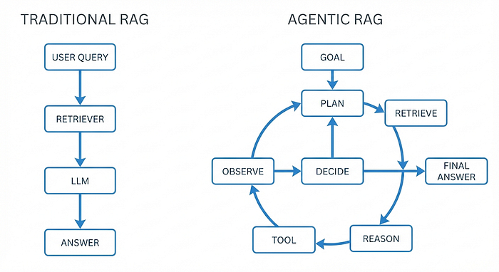

1.2. Agentic RAG reframes the problem
Agentic RAG treats the LLM as a control policy, not a response generator.
Instead of asking:
“What is the answer?”
The system asks:
- What is my current objective?
- What information do I need next?
- Which tool should I use to get it?
- Have I completed the task?
This introduces agency, defined as:
The ability to choose actions based on state and goals.

1.3. What “Agentic” Really Means (and What It Doesn’t)
An agentic system:
- Makes conditional decisions
- Uses tools deliberately
- Adapts based on observations
It does not mean:
- The model is autonomous without limits
- The system runs indefinitely
- The LLM executes code directly
Agency is bounded autonomy, enforced by system design.

2. Core Components of an Agentic RAG System
A production-grade agentic RAG system consists of five orthogonal components:
- LLM (Reasoning Engine)
- Retriever (Knowledge Access Layer)
- Memory (State Persistence)
- Tools (Action Interfaces)
- Controller (Decision Loop)
Each component must be independently testable and observable.
Press enter or click to view image in full size
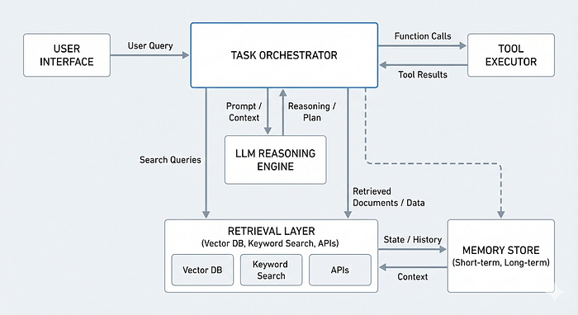

2.1 The LLM: Reasoning, Not Execution
The LLM’s role is cognitive, not operational. It is responsible for:
- Interpreting goals
- Decomposing tasks
- Planning next steps
- Selecting tools
- Synthesizing outputs
It must not:
- Directly query databases
- Execute system commands
- Control termination
This separation is critical for reliability.

Example: LLM decision output (structured)
{
"thought": "I need recent user complaints to identify patterns.",
"action": "search_documents",
"arguments": {
"query": "user complaints last 7 days"
}
}
The LLM decides. The system executes.

2.2 Retrieval Layer: Dynamic Knowledge Access
In agentic RAG, retrieval is not a preprocessing step. It is interactive. The agent may:
- Refine queries after partial results
- Switch between semantic and keyword search
- Query structured and unstructured sources

Retrieval interfaces (example)
class Retriever:
def semantic_search(self, query: str, k: int = 5) -> list:
...
def keyword_search(self, query: str) -> list:
...

Hybrid retrieval in practice
def retrieve_context(query):
semantic_results = retriever.semantic_search(query)
keyword_results = retriever.keyword_search(query)
return semantic_results + keyword_results
This avoids over-reliance on embeddings alone.

2.3 Memory: Maintaining State Across Steps
Without memory, agents repeat themselves.
Press enter or click to view image in full size
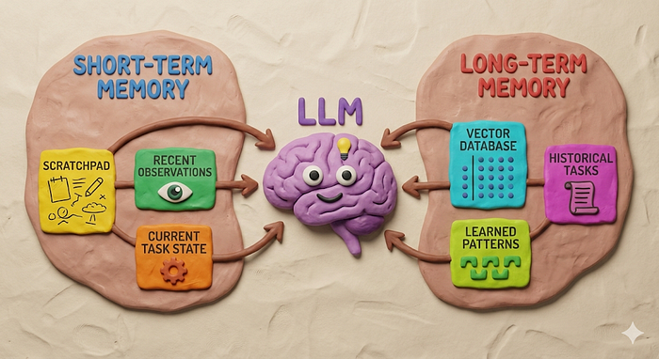
Agentic RAG requires explicit state management.

Short-term memory (task-local)
Stores:
- Current plan
- Tool outputs
- Partial conclusions
state = {
"goal": "Analyze user complaints",
"observations": [],
"decisions": []
}

Long-term memory (cross-task)
Stores:
- Historical tasks
- Learned preferences
- Past failures
Often backed by vector stores or databases.
memory_store.add(
text="Incident on 12 Jan caused by cache misconfiguration",
metadata={"type": "incident"}
)
Memory enables learning across executions.

2.4 Tools: Controlled Action Surfaces
Tools are pre-approved functions with strict schemas. They act as the agent’s hands.
Press enter or click to view image in full size
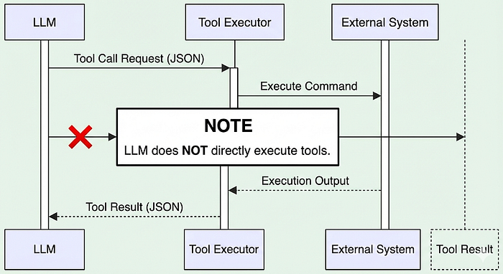

Example tool definitions
def search_documents(query: str) -> str:
return document_store.search(query)
def fetch_logs(start: str, end: str) -> str:
return log_service.fetch(start, end)
Key properties:
- Deterministic behavior
- Typed inputs
- No hidden side effects
The LLM never executes tools — it only requests them.

2.5 The Control Loop: Where Agency Exists
Agency does not live in the model. It lives in the loop. A robust control loop:
MAX_STEPS = 8
for step in range(MAX_STEPS):
decision = llm.decide(state)
if decision.type == "tool":
result = tools[decision.name](**decision.args)
state["observations"].append(result)
elif decision.type == "final":
break
This loop enforces:
- Step limits
- Observability
- Termination conditions
Press enter or click to view image in full size
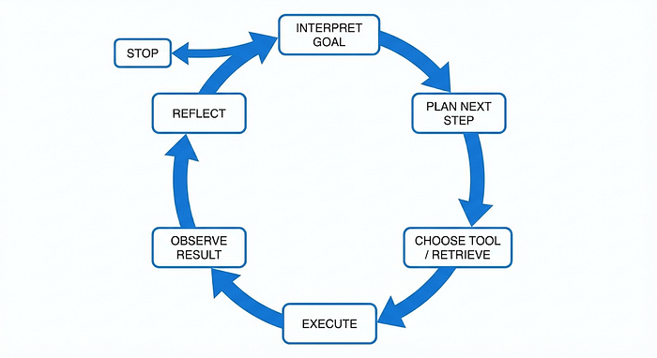
Without it, agents become unstable.

3. How Agentic RAG Works End-to-End

Task:
“Analyze recent user complaints and recommend fixes.”

Step-by-step execution
- Interpret goal
→ Identify subtasks
- Plan retrieval
→ Decide what data is needed
- Execute retrieval
→ Fetch complaints
- Analyze results
→ Identify patterns
- Conditional follow-up
→ Fetch logs if needed
- Synthesize outcome
→ Generate recommendations
Press enter or click to view image in full size
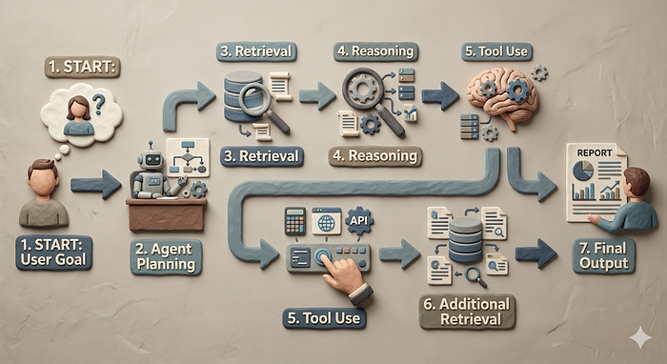
This is not a prompt. It is a stateful system.

4. Putting It All Together: A Complete Agentic RAG System
Below is a minimal but realistic implementation.

4.1 System Setup
class AgentState:
def __init__(self, goal):
self.goal = goal
self.history = []
self.done = False

4.2 LLM Decision Interface
def agent_step(state: AgentState):
prompt = f"""
Goal: {state.goal}
History: {state.history}
Decide next action.
Return JSON with:
- thought
- action (tool | final)
- arguments
"""
return llm.generate(prompt)

4.3 Tool Execution Layer
TOOLS = {
"search_documents": search_documents,
"fetch_logs": fetch_logs
}

4.4 Control Loop
state = AgentState(goal=user_task)
for _ in range(10):
decision = agent_step(state)
if decision["action"] == "tool":
result = TOOLS[decision["arguments"]["tool"]](
**decision["arguments"]["params"]
)
state.history.append(result)
elif decision["action"] == "final":
output = decision["arguments"]["answer"]
break
This is a complete Agentic RAG system:
- Goal-driven
- Tool-using
- Bounded
- Observable

5. Simple Agentic RAG using Langchain

6. Common Failure Modes (and Why They Happen)

❌ Infinite loops
Cause: No termination logic
Fix: Hard step limits

❌ Hallucinated tool calls
Cause: Weak tool schemas
Fix: Strict validation

❌ Context explosion
Cause: Dumping all memory into prompts
Fix: Summarize and compress state

❌ Over-agentification
Cause: Using agents where RAG suffices
Fix: Start simple

7. When You Should (and Shouldn’t) Use Agentic RAG

Use Agentic RAG when:
- Tasks are multi-step
- Decisions depend on results
- Multiple tools are involved

Avoid it when:
- A single retrieval answers the question
- Latency and cost are critical
- Deterministic logic suffices
Agents are powerful — but expensive.

Key Takeaways
- Agentic RAG extends RAG from answers to actions
- The LLM plans; the system executes
- Retrieval becomes iterative
- Memory enables learning
- Control loops define intelligence boundaries

Future Outlook
Agentic RAG is evolving toward:
- Multi-agent collaboration
- Long-horizon planning
- Self-correction loops
- Tool-specialized agents
But the core principle will remain:
LLMs are not products. They are components inside systems.

Final Thought
Agentic RAG is not about making LLMs more powerful.
It is about engineering environments where intelligence can safely operate. That is how AI moves from demos to real-world systems.

